

REact Life cycle

1. **Explain Life cycle in Class Component and functional component with Hooks.**

* Each component in React has a lifecycle which you can monitor and manipulate during its three main phases.
* There are three phase of react life cycle.
  + - Mounting
    - Updating
    - Unmounting
* Mounting:
* The mounting phase is when a new component is created and inserted into the DOM and rendered for the first time on the webpage.
* The mounting phase consists of two such predefined functions as described below.
* constructor
* static getDerivedStateProps
* render()
* componentDidMount()
* The render() method is required and will always be called, the others are optional and will be called if you define them.
* The constructor() method is called before anything else, when the component is initiated, and it is the natural place to set up the initial state and other initial values.
* The constructor() method is called with the props, as arguments, and you should always start by calling the super(props) before anything else, this will initiate the parent's constructor method and allows the component to inherit methods from its parent.

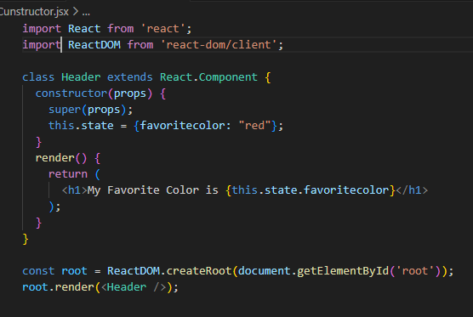

* static getDerivedStateProps:
* The getDerivedStateFromProps() method is called right before rendering the element(s) in the DOM.
* This is the natural place to set the state object based on the initial props.
* It takes state as an argument, and returns an object with changes to the state.
* The getDerivedStateFromProps method is called right before the render method.
* componentDidMount:
* The componentDidMount() method is called after the component is rendered.

### U getDerivedStateFromProps

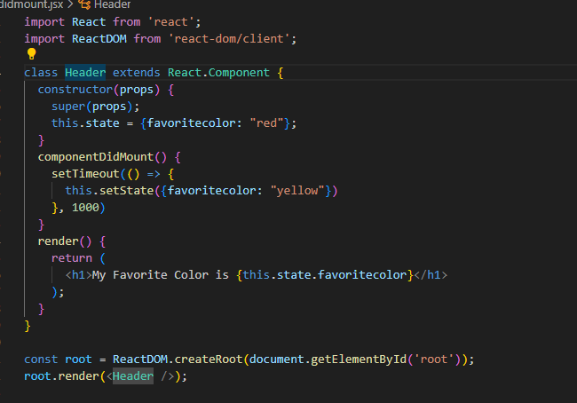

* Updating:
* The next phase in the lifecycle is when a component is updated.
* A component is updated whenever there is a change in the component's state or props.
* React has built-in methods that gets called, in this order, when a component is updated:
* getDerivedStateFromProps()
* shouldComponentUpdate()
* render()
* componentDidUpdate()
* getDerivedStateFromProps
* Also at updates the getDerivedStateFromProps method is called. This is the first method that is called when a component gets updated.
* This is still the natural place to set the state object based on the initial props.
* shouldComponentUpdate:
* In the shouldComponentUpdate() method you can return a Boolean value that specifies whether React should continue with the rendering or not.
* The default value is true.
* Render:
* The render() method is of course called when a component gets updated, it has to re-render the HTML to the DOM, with the new changes.
* componentDidUpdate:
* The componentDidUpdate method is called after the component is updated in the DOM.
* When the component is mounting it is rendered with the favorite color "red".
* When the component has been mounted, a timer changes the state, and the color becomes "yellow".
* The componentDidUpdate method is called after the update has been rendered in the DOM

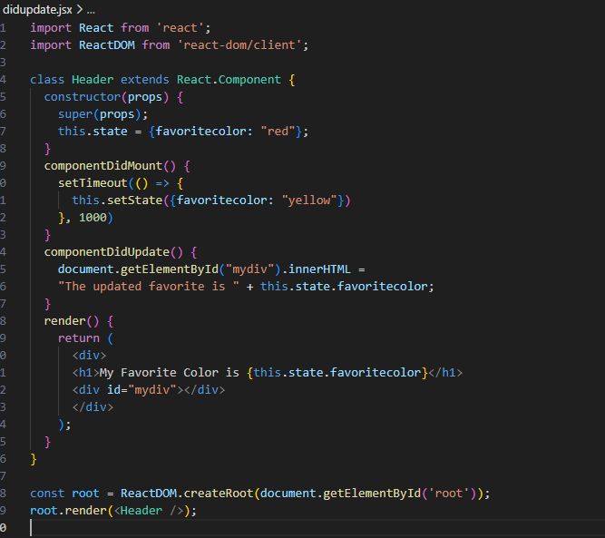

* Unmounting:
* The next phase in the lifecycle is when a component is removed from the DOM, or unmounting as React likes to call it.
* React has only one built-in method that gets called when a component is unmounted:
* componentWillUnmount()
* componentWillUnmount():
* The componentWillUnmount method is called when the component is about to be removed from the DOM.

